**User Guide**

This is a support document for users who run into problems with usage of the program.

The software is designed to provide a simple interface for users to keep a track of the crypto currency they hold and its value, in real time.

Contents

Usage: 1

Frequently Asked Questions (FAQ) 5

# Usage:

When the program is started you will be presented with the initial screen.

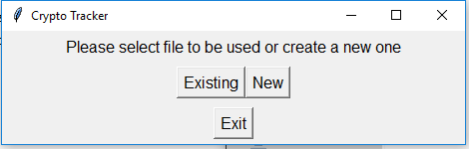

Here you have 3 options:

1. Choose an existing file that you have created previously to read and check your holdings or make changes to them. An open window will show, and you simply navigate to where the file you wish to open is located.

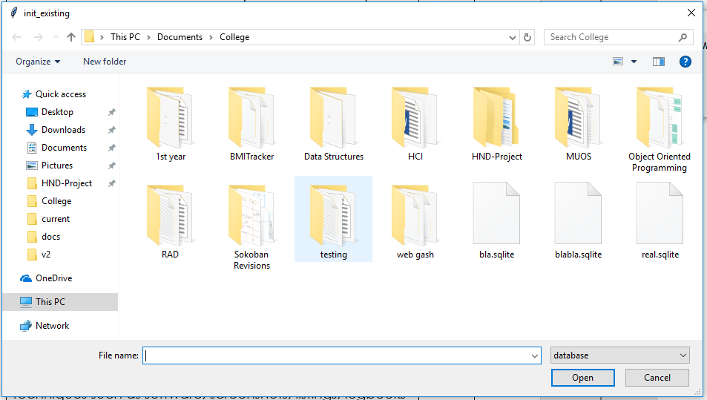

1. Create a new blank file to start a fresh portfolio, or if another user wants to have their own separate file. A save window will show, and you simply navigate to where you wish to save your new file and enter what you would like it to be called.

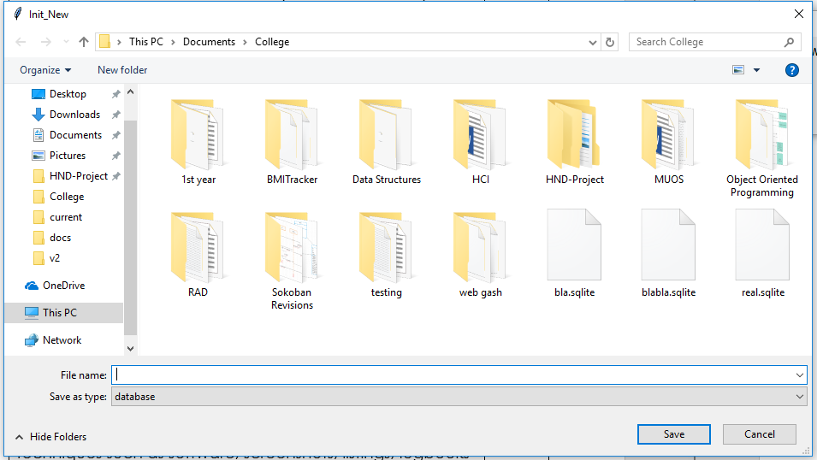

1. Exit the program

Once either a file is selected or created you will be presented with the main screen. Here I chose to create a new file:

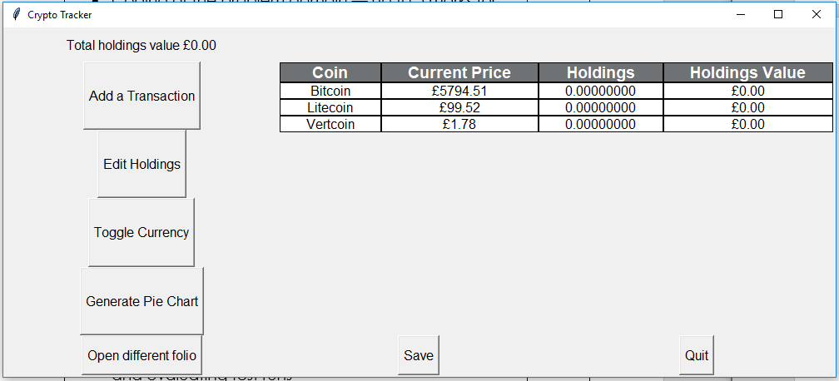

I will go through the options available on this page and their functions first going down the text and buttons on the left, then the two along the bottom and finally the table at the top right of the screen.

1. “Total holdings value:” This simply displays the sum of all your holdings. As there are no entries in this file yet, it is equal to £0
2. “Add a Transaction” button: This button is used when you wish to add a new amount of coin purchased to your portfolio. It opens another form whose usage is explained here.
3. “Edit Holdings” button: This is similar to the Add a transaction button. It is used to edit the amount of a coin you are holding. For example if you sold some coin, or entered an incorrect amount when adding previously. It opens another form whose usage is explained here.
4. “Toggle Currency” button: This is used to toggle between the available currencies. These are GBP, USD and EUR. When clicked, the displayed total and table will be refreshed with the converted prices of coins, as well as your holdings value in the new currency.
5. “Generate Pie Chart” button: This is used to create an pie chart, which is then saved as an individual .png file. Again, you are presented with a save window where you choose the directory and name you would like to save as. It uses the monetary value of each coin you are holding, rather than the amount of each you are holding.
6. “Open different folio” button: This brings up an open window exactly like the one found when the “Existing” button is pressed on the initial window shown when you start the program. From here you choose an existing file, and the main form will be updated to show this new data.
7. “Save” button: This brings up a save window exactly like the one found when the “New” button is pressed on the initial window shown when you start the program. From here you choose a location and filename to save your current holdings to. This is akin to “Save As” options included in many other pieces of software.
8. “Quit” button: This exits the program.
9. Table at the top right: This table is used to show a breakdown of each coin. The columns from left to right are:

* Coin – This is simply the coin name
* Current Price – This is the live price of the coin according to Coinmarketcap.com
* Holdings – This is the amount of coin you have entered as holding. NB – Always displayed to 8 decimal places as the is the maximum that crypto currencies can be broken into.
* Holdings Value – This is the value of your holdings for that coin, calculated based on current price and the holdings you have entered.

“Add a transaction” window:

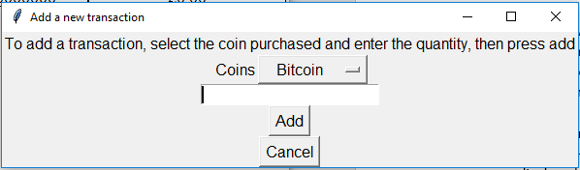

I will go through the options on this page from top to bottom.

1. “Coins” dropdown box: This shows a list of coins available for you to add to the file you have loaded. The options are “Bitcoin”, “Litecoin”, and “Vertcoin”.
2. Text box below this: Here you enter the number of coins you would like to add.
3. “Add” button: This adds the data entered to the file you have opened and brings you back to the main page.
4. “Cancel” button: This brings you back to the main page without any changes being made.

“Edit Holdings” window:

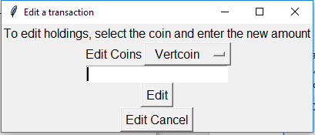

I will go through the functions on this page from top to bottom:

1. “Edit Coins” dropdown box: This allows you to select the coin you wish to edit your holdings for.
2. Textbox: This is where you enter the new amount of the chosen coin you are holdings
3. “Edit” button: This makes the changes you have entered to the file you currently have open.
4. “Edit Cancel” button: This brings you back to the main page without making any changes.

# Frequently Asked Questions (FAQ)

* I have tried to select a file, but it won’t open on the main page:
  + This is normally caused if you have select a file of the same type, but one not generated by the program. In this case, make sure you are selecting a file created by this program.
  + Another common cause of this is if the database file has become corrupt. In this case either select another file or create a new one to use.
* I want to add a coin, but it isn’t available:
  + This feature isn’t currently supported but may be added in later versions.
* I want to display my holdings in a different currency that isn’t included:
  + This feature isn’t currently supported
* I am trying to add or edit my holdings, but I keep getting an error:
  + Make sure you are entering valid data into the Add or Edit windows. Valid data must be above 0 for adding, or Equal to or greater than 0 for editing.